# Hostel Management System



**NAGULAN -22CDR059**

**NISHWAN -22CDR062**

**NITHISKUMAR –22CDR064**





















**BONAFIDE CERTIFICATE**

**Name** : NAGULAN (22CDR059) NISHWAN (22CDR062)

NITHISKUMAR (22CDR064)

**Course Code** : 22CDL41

**Course Name** : DATABASE MANAGEMENT SYSTEM LABORATORY

**Semester** IV

Certified that this is a bonafide record of work for application projects done by the above students for **22CDL41 – DATABASE MANAGEMENT SYSTEM LABORATORY**

during the academic year **2023 - 2024.**

Submitted for the Viva Voce Examination held on

**Faculty In-Charge Head of the Department**

# Hostel Management System

## ABSTRACT

* **INTRODUCTION**

## SYSTEM REQUIREMENT SPECIFICATION

* **SYSTEM FLOW CHART**

## ER - DIAGRAM

* **IMPLEMENTATION**

## SAMPLE INPUT AND OUTPUT

* **CONCLUSION AND FUTURE ENHANCEMENT**

## ABSTRACT

* A simple project based on an Online Hostel Management System that uses PHP language with MySQL database. Following PHP MySQL project contains all the essential features which can be in use by first-year IT students for their college projects. It has a number of features that will allow users to manage the hostel’s student details.
* This system as well as the web application’s concept is all clear. It’s the same as real-life scenarios and well-implemented on it. It mainly focuses on the efficient handling of student registrations, room allocations, fee management, and maintenance requests, maintaining data integrity and security.
* Our Hostel Management System is built on top of a relational database model to store and manage voluminous data. The system comprises modules for user authentication, student information management, room and bed allocation, fee tracking, and incident reporting. The system will also have an interactive interface for administrators, staff, and students.

## INTRODUCTION

* 1. **Overview of the Project**
* In particular, this Online Hostel Management System Project in PHP focuses mainly on booking hostels and their management sides. To be more precise, the system helps students to register and book hostel rooms online.
* Also, the system contains all the students, and room management features with it. In addition, the system allows for managing student registration, course, room management, and more. Evidently, this project contains an admin panel with a student panel. In an overview of this web application, registered students can simply book hostel rooms and view booked room details.
* For booking a hostel, the student has to select a room number, hostel features, duration, enter personal details, and more, the student can view their room details which include room number, features, total fees, duration, and more.
* The project entitled as **“Hostel Management System”** is developed in a manner to help all the hostel students. It is developed using PHP and MySql.

**SYSTEM REQUIREMENT SPECIFICATION**

* 1. **Specification**

PHP version : 5.6, 7.4

RAM : 512 MB DDR 2

Hard Disk : 80 GB

Floppy disk : 1.44MB

* 1. **Software Specification**

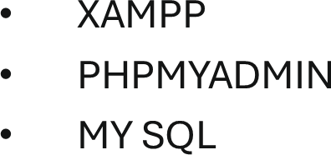

## System Flow Diagram

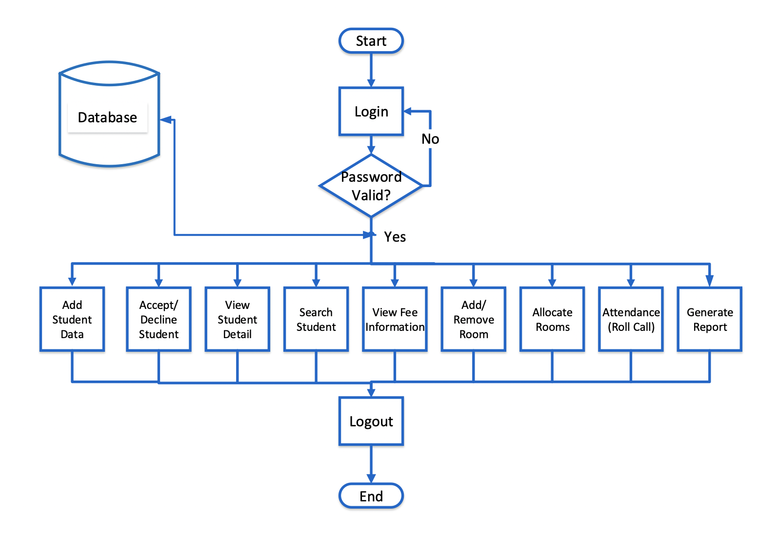

* 1. **ER - DIAGRAM**

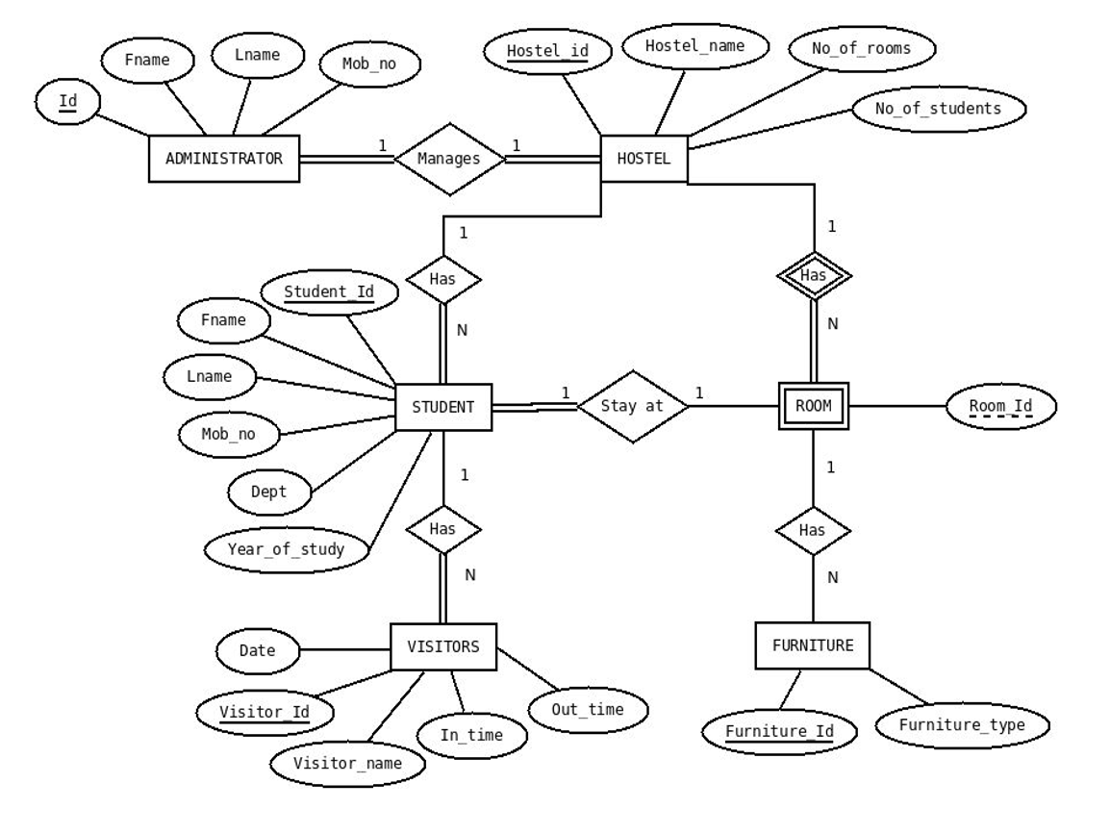

## IMPLEMENTATION

### **1. Database Methods**

#### a. Database Connection

* **Connect to the Database**: Establish a connection to the MySQL database to perform operations like insertion, selection, updating, and deletion of records.

#### b. CRUD Operations

* **Create**: Insert new records into the database, such as new student registrations, room allocations, and fee records.
* **Read**: Retrieve data from the database, such as student details, room availability, and fee statuses.
* **Update**: Modify existing records in the database, such as updating room assignments or fee payment statuses.
* **Delete**: Remove records from the database, such as deregistering students or deleting outdated records.

### **2. User Interface Methods**

#### a. Form Handling

* **Student Registration Form**: Collect and handle input data for registering new students.
* **Room Assignment Form**: Collect and process data to assign rooms to students.
* **Fee Management Form**: Manage and update fee-related information for students.

#### b. Validation

* **Input Validation**: Ensure all user inputs are valid and sanitized to prevent errors and security vulnerabilities.
* **Server-Side Validation**: Validate data on the server-side to ensure robustness and security.

### **3. Business Logic Methods**

#### a. Student Management

* **Register Student**: Handle the process of registering a new student, including storing their details in the database.
* **View Student Details**: Retrieve and display detailed information about a student, such as personal details, room assignment, and fee status.

#### b. Room Management

* **Assign Room**: Allocate a room to a student based on room availability and capacity.
* **Check Room Availability**: Determine whether a room is available based on current occupancy and capacity.
* **Update Room Occupancy**: Update the number of students currently occupying a room.

#### c. Fee Management

* **Record Fee Payment**: Log fee payments made by students and update their fee status.
* **View Fee Status**: Retrieve and display the fee payment status for a student.
* **Generate Fee Reports**: Create reports to summarize fee payments, outstanding amounts, and financial statuses.
  1. **OUTPUT**

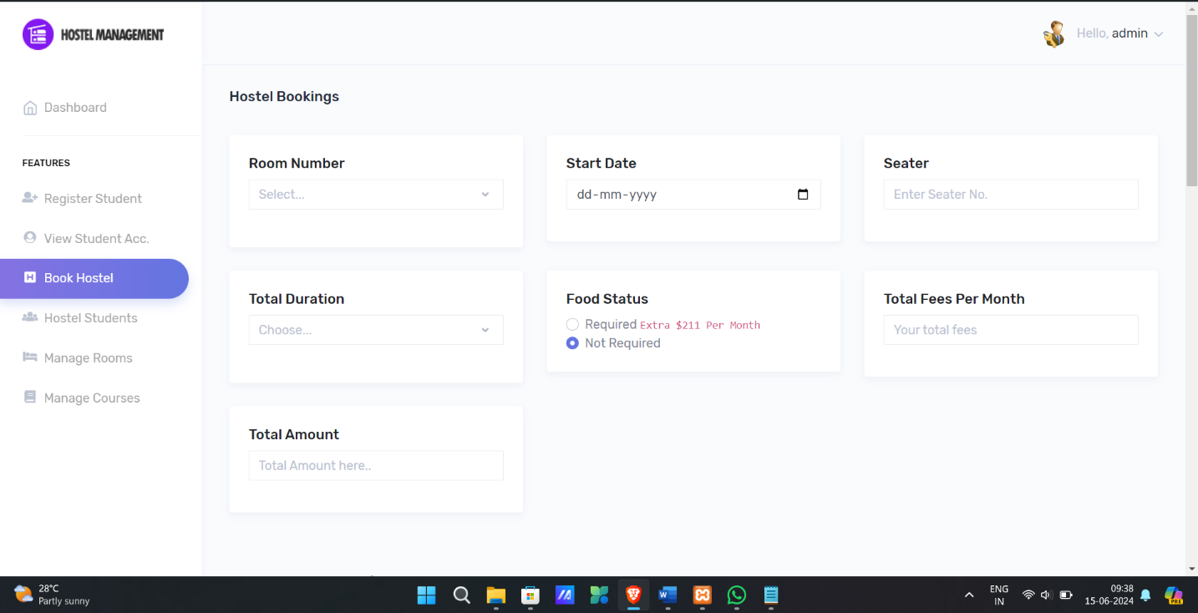

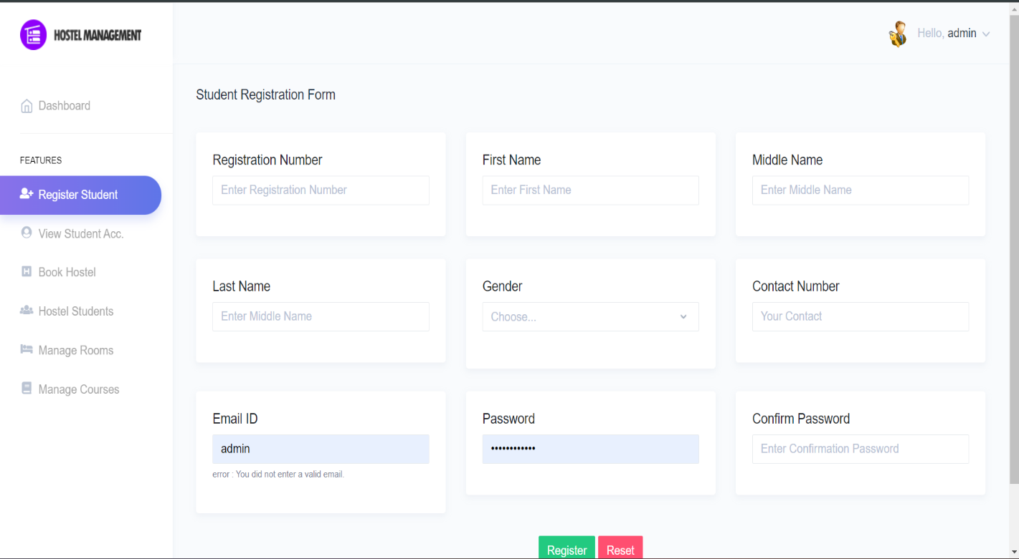

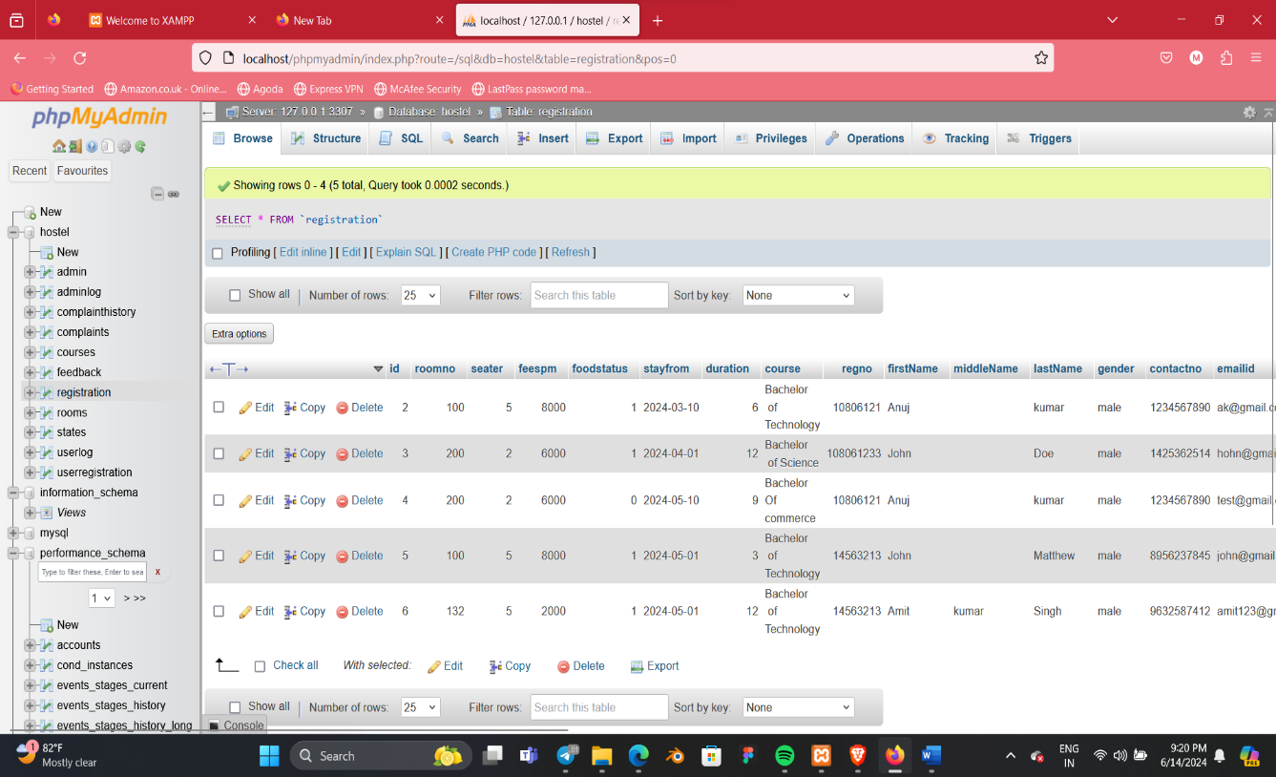

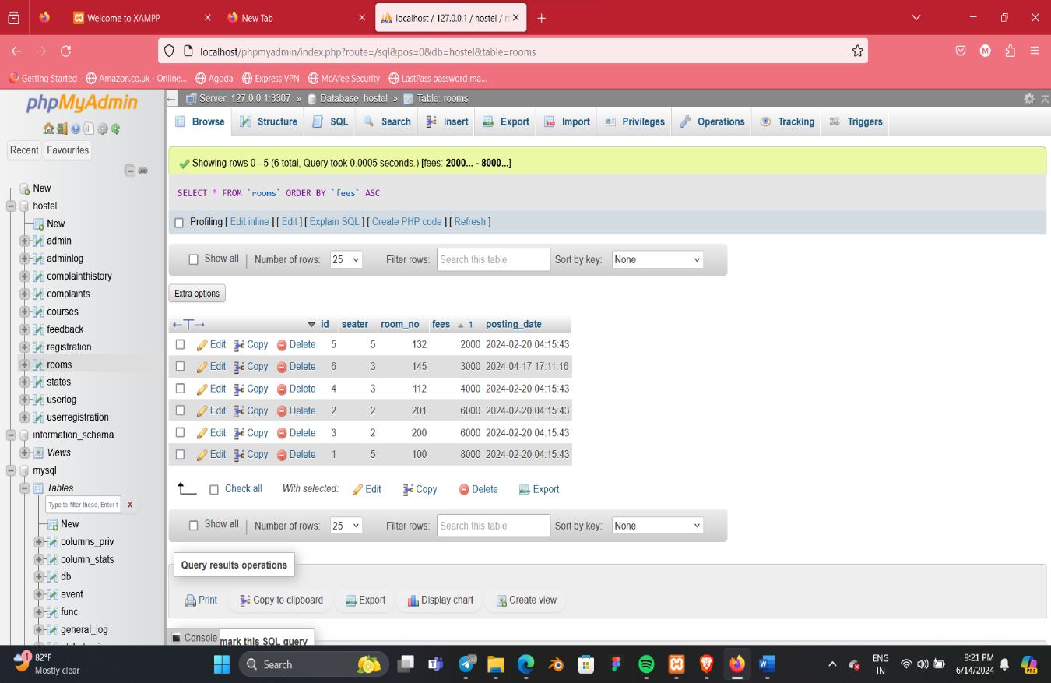

* 1. **CONCLUSION AND FUTURE ENHANCEMENT**

### **Enhancements**

To further improve the hostel management system

**Advanced Reporting**

* Develop advanced reporting features that provide detailed insights into hostel operations, including occupancy trends, fee collection status, and student demographics.

**Room Management Enhancements**

* Implement features for room maintenance tracking, allowing staff to log maintenance requests and updates.

**Automated Backups**

* Set up automated backups of the database to ensure data is securely stored and can be restored in case of data loss.

By implementing these enhancements, the hostel management system can become more comprehensive, user-friendly, and adaptable to the needs of various stakeholders.

## REFERENCES

• Apache Friends. (2023). XAMPP - Apache + MariaDB + PHP + Perl. Retrieved from <https://www.apachefriends.org>